CANDLESTICK SIGNALS

Why I Love Candlestick Charts
I came across this stock the other day and I just became fascinated with the price action in this stock. It also reminded me why I am such a big fan of candlestick charts.
Take a look at the following chart and follow along below...
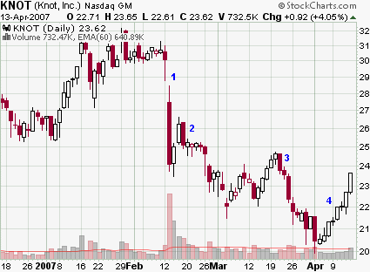
1) This stock was in a nice uptrend until the big gap down with a wide range candle on massive volume. These types of moves are institutionally driven and often ignite new trends.
2) After a short two-day bounce, a bearish engulfing candle forms. Engulfing candles are my all time favorite candlestick pattern. While other candlestick patterns show a slowing of momentum, engulfing candles tell you for a fact that the other side has taken control of the stock.
Of course this can change on the following day but at that point in time, you have confirmation that a reversal is taking place.
Over the next several days, narrow range candles develop that stay near the bottom of that engulfing candle. This shows weakness on the part of the buyers. If they can't even move the stock very far into the prior days range, then you have to assume that sellers will take control of the stock again. And they did.
3) After a five day rally another engulfing candle forms. We know for a fact that sellers have completely overwhelmed the buyers. Those who bought into this rally are now questioning their decision. Fear creeps in and the stock tanks.
4) This stock first showed up on my scan with the doji at $22.00. I thought, "Hey this might be a great shorting opportunity." While a doji tells you that a slowing of momentum has occurred, it really doesn't signal a reversal in and of itself. It tells you that a reversal could happen. It didn't.
So now we have an interesting rally. It started out innocent enough with just a couple of narrow range candles, but now it has expanded into a strong rally. Greed is beginning to set in as the daily ranges expand.
This stock has retraced too much of the prior swing for me to consider shorting this stock now, but at the very least this stock will consolidate. It may reverse. Heck, maybe another engulfing candle will develop.
So, while a regular old bar chart gives you the same information, a candlestick chart paints pictures of human emotions. That's why I love candlestick charts. As a discretionary trader, I need these pictures to make good trades!

